Task 1:
Implemented a simple Baby Monitoring System (In-Class Example) using Java Observable with:
- Push strategy
- Pull strategy

Task 2
The upcoming Guitar Hero XIII: Legends of Rock needs a player configuration system. Guitar Hero XIII lets you play three different characters (Slash, Jimi Hendrix, and Angus Young). Each character can play one of three available guitars (Gibson SG, Fender Telecaster or Gibson Les Paul) and perform a unique solo act (Put the Guitar on Fire, Jump off stage, Smash the Guitar).

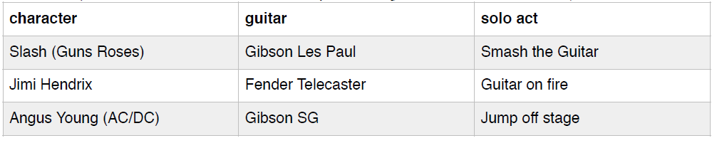
- Implement a player configuration system in Java using the Strategy design pattern.
- Some guitar players trash their guitars on stage. Modify your code so players can change guitars on the fly.
- Draw a class diagram of your design.

